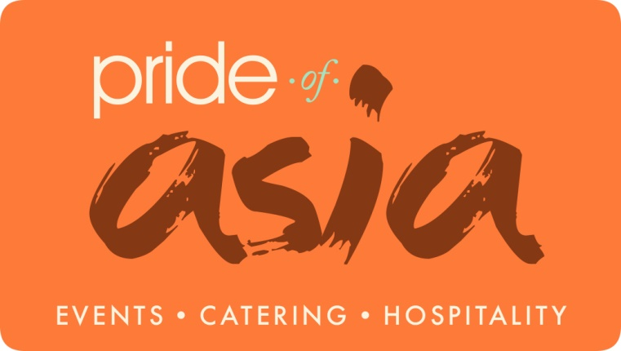
CANAPES

VEGETARIAN:
- Cocktail Veg Spring Rolls
- Cocktail Paneer Spring Rolls
- Mini Onion Bhaji( Pakoras)
- Mini Onion Rings ( Battered or breadcrumb)
- Cocktail Mini Aloo Tikki
- Cocktail Cheese with Olives
- Cocktail Feta Cheese with Chilli Olives
- Chilli Paneer
- Cocktail Tandoori Paneer Tikka
- Cocktail Vegetable Samosa
- Paneer Potli
- Cheese Pockets
- Cocktail Paneer Samosa
- Aloo Papri Chaat (in spoons)
- Pani Puri Shots
- Tandoori Mushrooms On Skewers
- Crispy Coated Mushrooms
- Cocktail Falafels
- Paneer Pudhina Pakora
- Achari Paneer Tikka

CANAPES

NON VEGETARIAN:

- Chicken Pakora
- Chicken Tikka
- Cocktail Lamb Samosa
- Cocktail Seekh kebabs
- Cocktail Mini Shami Kebabs
- Cocktail Kofta
- Kaati Kebab Rolls
- Zeera Chicken
- Coconut Breaded Butterfly King Prawns
- Filo pastry king prawns
- Tempura king prawns
- Mini smoked Salmon Bagels with cream cheese
- Cocktail Chicken Samosa
- Mini Sliders
- Fish & Chip Cones
- Prawn Puri
- Cocktail Masala Fish

